**CS 116 Project 4 Object Detection Report**

Anthony Liu – 79553180

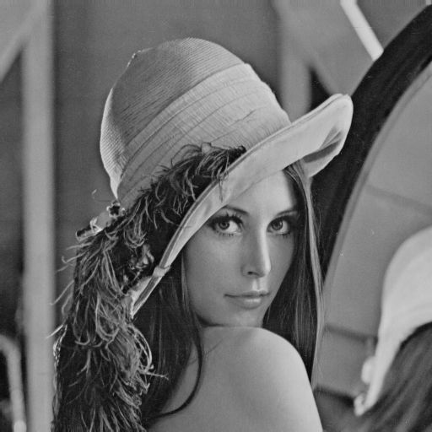

**Figure 1**. Original sample testing mygradient.m (lena512.pgm)

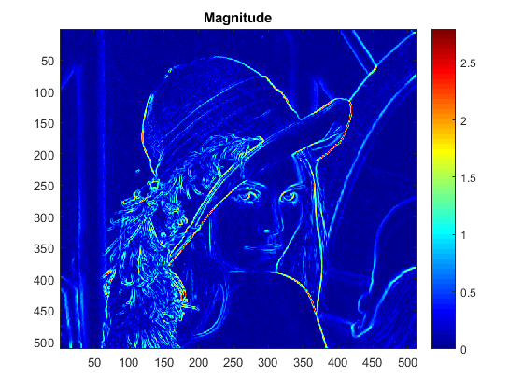

**Figure 2(a)**. Magnitude generated from mygradient.m

A close up of a logo

Description generated with high confidence

**Figure 2(b).** Orientation in degree generated from mygradient.m

**Testing detection code – Part I**

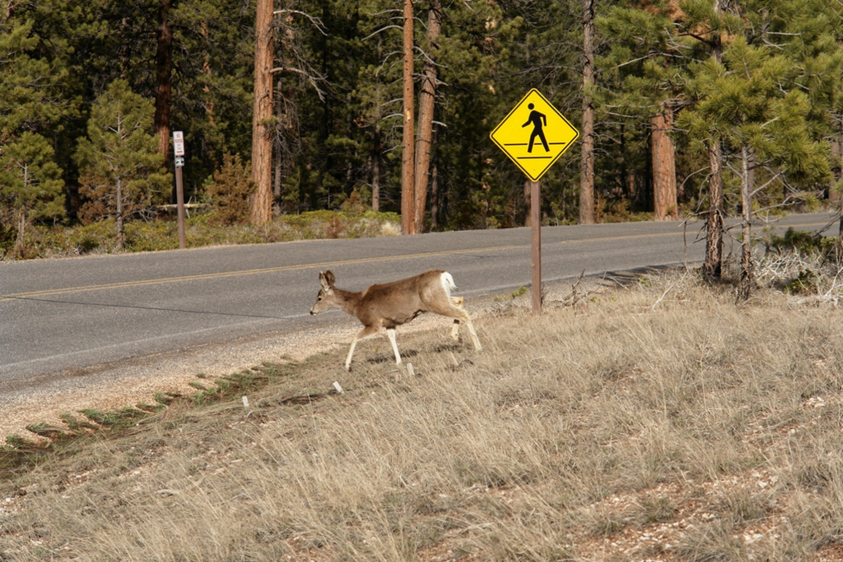

**Figure 3**. Original image for testing detection (part I)

A close up of a logo

Description generated with very high confidence

**Figure 3(a)**. Positive training sample selected

A close up of a green background

Description generated with high confidence

**Figure 3(b).** Negative training sample selected – wood, deer, grass

A sign on the corner of a street

Description generated with very high confidence

**Figure 3(c)**. Detection result using similar photo

**Testing detection code – Part II**

**A person wearing a suit and tie

Description generated with very high confidence**

**Figure 4**. Original image – photo of former US president Obama (Part II)

A close up of a mans face

Description generated with very high confidence

**Figure 4(a)**. Positive training sample selected – eyes

A close up of a mans face

Description generated with high confidence

**Figure 4(b).** Negative training sample selected – nose, ear, tie

A person wearing a suit and tie

Description generated with very high confidence

**Figure 4(c).** Detection result using similar photo – fair accuracy

**Testing detection code – Part III**

**A red stop sign sitting on the side of a road

Description generated with very high confidence**

**Figure 5**. Original image of a stop sign on a street corner (Part III)

A close up of a logo

Description generated with high confidence

**Figure 5(a).** Positive training sample selected – close-up of sign

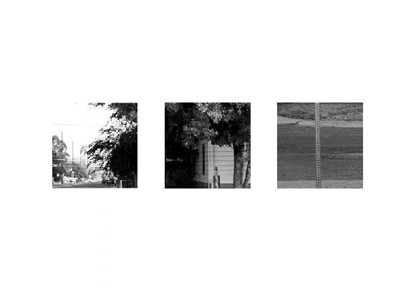

**Figure 5(b)**. Negative training sample selected

A sign on a pole

Description generated with high confidence

**Figure 5(b)**. Detection result using similar photo – high accuracy

**Conclusion**

Concluding from the above samples and other experiments with our detection code, the model performed well with the training data selected. As shown above, the detection successfully detected and shown the best candidates as our expected outcome.

However, through further experimentations, we found that the detection worked poorly when objects have complex structures or definitions. For example, the detection failed with images of people with different facing or facial expressions. While there could possibly be coding defects, the underperformance was primarily due to i) the limited size and ii) the limited variation of our training data. Thus, we need to allow onloading more training images. Furthermore, for images with low resolutions, it has been found that they negatively affected our detection accuracy.